SRI DNR GDC (W), PALAKOL
{NAAC RE-ACCREDITED WITH B GRADE (CGPA 2.61}
WEST GODAVAR1 Dist., A.P., Pin. 534260

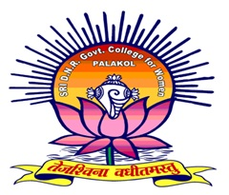

DEPARTMENT OF COMPUTER SCIENCE

FIELD VISIT 27-12-2021

SRI DNR GDC (W), PALAKOL
{NAAC RE-ACCREDITED WITH B GRADE (CGPA 2.61}
WEST GODAVAR1 Dist., A.P., Pin. 534260
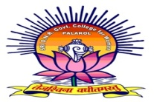
DEPARTMENT OF COMPUTER SCIENCE
FIELD VISIT 27-12-2021

SRI DNR GDC (A), PALAKOL Department of Computer Science conducted field visit to , Palakol for 3rd B. Sc II BSC students on 27-12-2021. 20 students from III BSC(MPCS ) & II BSC( MPCS) groups along with Two Lecturers of Dept. of Computer Science R.Sailaja & V.Mamatha have participated in this Field Trip, To get the Knowledge of Software Industry in Every Day Life and to get practical experience about the Use of Softwares .HR MisV.Devi and Developer Mr.K.Prasad has explained about product based and service based companies to the students.

Signature of the faculty: 1.R.Sailaja
2.V.Mamata

SRI DNR GDC (W) PALAKOL
DEPARTMENT OF COMPUTER SCIENCE
FIELD TRIP
NETENRICH & OPS RAMP SOFTWARE COMPANIES, PENNADA
27-12-2021

Computer Science department have conducted a field trip to NETENRICH AND OPS RAMP software companies in Pennada near Bhimavaram on 28-12-2021 .computer science guest faculties R.Sailaja and V.Mamatha coordinated and taken to field trip. Total 20 students from III Bsc, IIBsc (Mpcs) were came and acquire knowledge about software companies their requirements , domain and what are the process going in working environment. And we coordinated with HR of the company for internship programs to our students.
